User Guide 41 Planning Permit Application Fees
Purpose of this User Guide
The purpose of this User Guide is to assist applicants and Responsible Authorities about the payment of planning permit application fees.
Who should read this?
Primary audience: Applicants
For information: Responsible Authorities and referral authorities
Introduction
SPEAR provides online payment functionality for all planning permit and certification statutory fees, and any other fee which needs to be paid to the Responsible Authority during the life of the application. Fee payments to referral authorities are not handled within SPEAR; contact the relevant referral authority for information on how to pay fees and charges levied by those authorities.
The function is initiated when the Applicant Contact selects:
- ‘Submit Application & Pay Fee’ from the Submit Application screen, or
- ‘Pay Fee to Responsible Authority’ from the optional actions on the Details tab, or
- ‘Calculate Statutory Fees’ from the optional actions on the Details tab, or
- When a guest to an application selects the optional action to ‘Pay Fee to a Responsible Authority’.
NOTE: Not all Responsible Authorities accept online payments.
Responsible Authorities offering online payments can select from two different online payment methods:
- The Responsible Authority accepts online credit card payments from within SPEAR via the Westpac Quickweb system. The SPEAR and Westpac screens will be displayed.
- The Responsible Authority accepts online payments via another website. A Pay Fee to Responsible Authority Introduction screen is displayed, with a link to the Responsible Authority’s payment website, which opens in a new window.
Screen images within this User Guide are of the SPEAR and Westpac payment screens. If the Responsible Authority you are lodging with uses another website for payments, or does not accept online fee payments, the screens will differ from those pictured in this guide.
41.1 Submitting an application to a Responsible Authority
When an applicant selects ‘Submit application’ they will be presented with the following two options:
- ‘Lodge your application and pay the applicable statutory fee’ - The system will invoke the relevant payment function immediately after submission of the application.
- ‘Lodge your application without paying the fee’ – The application is submitted, and payment can be made within SPEAR or outside of SPEAR later. This will also allow a guest to make a payment. See User Guide 39 for details on Guest access to SPEAR applications.
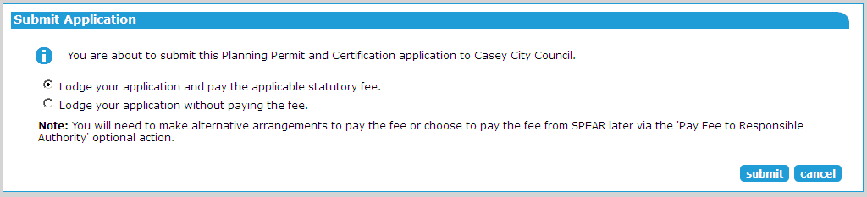

41.2 Pay fee on submission of application
If electing to submit the application with fee, the Pay Fee to Responsible Authority screen is displayed. The Applicant Contact (or guest) must complete the fields on this screen to confirm the amount and the type of the fee payment, and click ‘next’.
If council has elected to set a surcharge on their payments, it will also be shown on this screen.
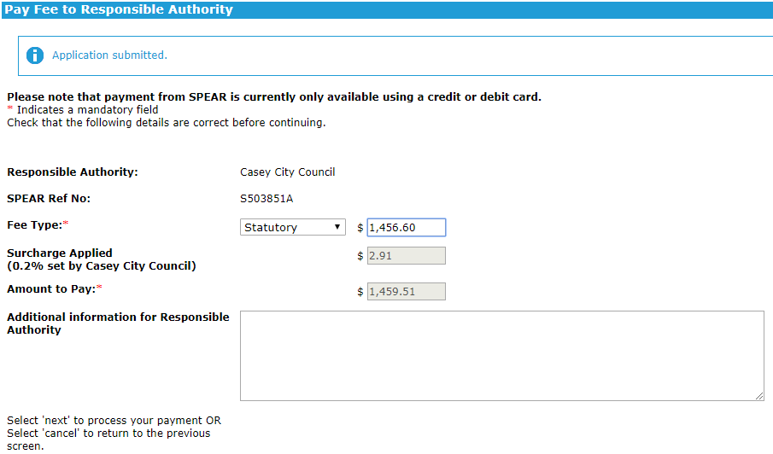

The Westpac Payment Details screen is then displayed. Enter the relevant credit card details and click ‘Next’ to proceed.
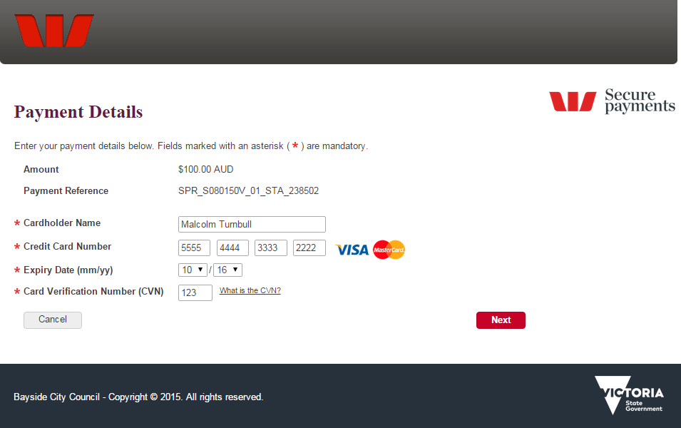

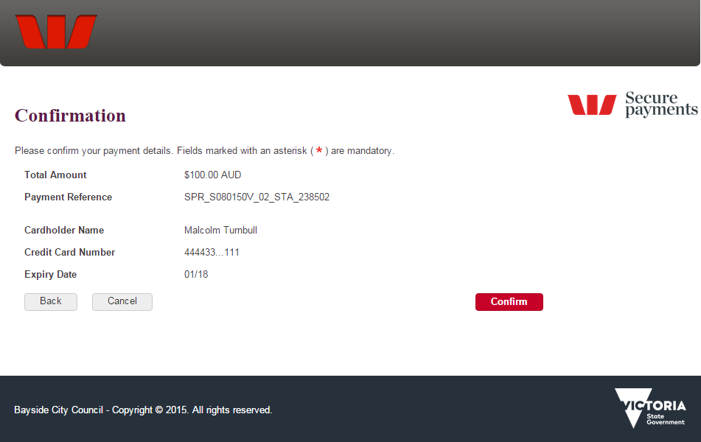
After entering your credit card details a confirmation screen will appear. Click ‘Confirm’ to proceed with the payment.

Once completed, the applicant will be returned to SPEAR and a record of the payment will appear as a document in the Applicant Contact section of the Details screen. There is no limit to the number of payments that can be processed within a SPEAR application.
NOTE: If the Responsible Authority is using another website to process online fee payments, a new window will appear for that service instead. Payments made through a non-SPEAR service will not be recorded in SPEAR, and the user should contact the Responsible Authority to notify them of the payment.
41.3 Pay fee at a later date
If the payment is to be made at a later date, the Applicant Contact can select either of two optional actions to process an online payment within SPEAR:
- Select the optional action ‘Calculate Statutory Fees’ and click ‘go’ to invoke the Fee Calculator. This will display the statutory fees payable. The applicant can then click the online now link to be directed to the fee payment screen shown in 41.2, above.
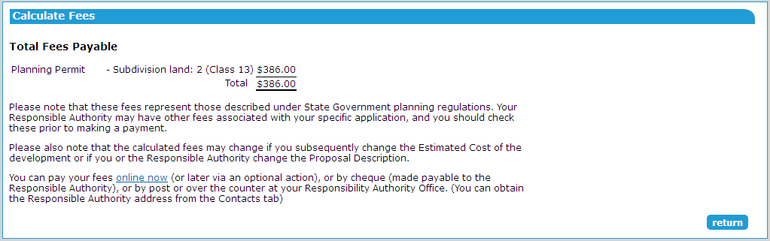
- Alternatively, select the optional action ‘Pay Fee to Responsible Authority’ and click ‘go’ to move directly to the fee payment screens shown in 41.2, above. This option can also be used to pay subsequent fees, such as advertising or inspection fees.
41.4 Guest payment of a fee
A guest user can pay fees to a Responsible Authority accepting online payments. From the Details tab within an application, select ‘Pay Fee to Responsible Authority’ from the Other Actions drop-down list and click ‘go’. The fee payment screens will be displayed, as shown in 41.2 above.
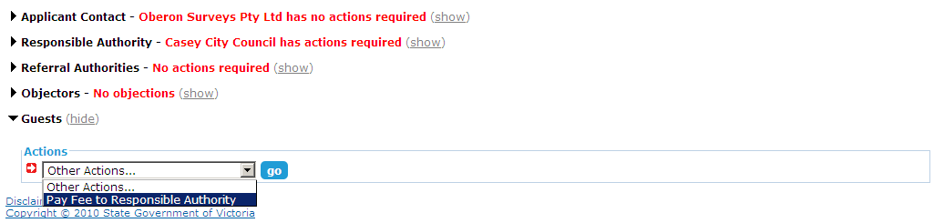

See User Guide 39 for details on Guest access to SPEAR applications.
41.5 Who to contact with payment issues
- If there is a problem with the SPEAR Payments system, contact the SPEAR Service Desk on 9194 0612.
- If there is a problem with the Responsible Authority payment system or the fee payable, contact the Responsible Authority (This information is available from the Contacts tab).
- If there is a problem with SPEAR contact the SPEAR Service Desk.
Need more information?
Further information on this topic can be found by:
- Visiting the SPEAR website www.spear.land.vic.gov.au/SPEAR
- Contacting the SPEAR Service Desk on 9194 0612 or email spear.info@delwp.vic.gov.au
- Selecting the Help link in the relevant area of the system.

